Nama : Ariningtyas Hetsbi Islami

NIM : 18090029

Kelas : 5B

***PRAKTIKUM 2***

1. Source Code

viewlatihan1.php->application/views

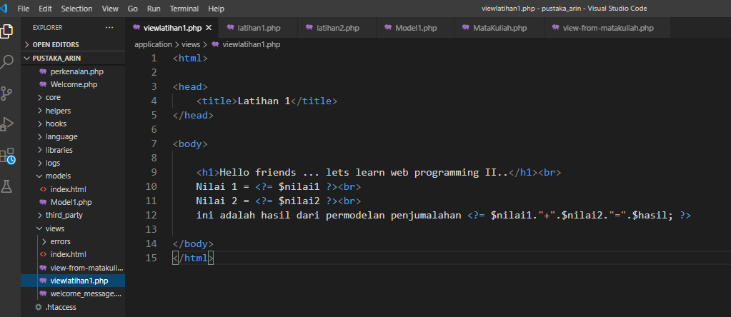

latihan1.php->application/controllers

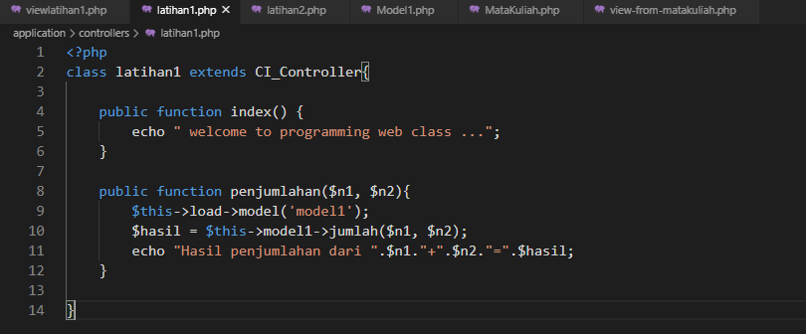

latihan2.php->application/controllers

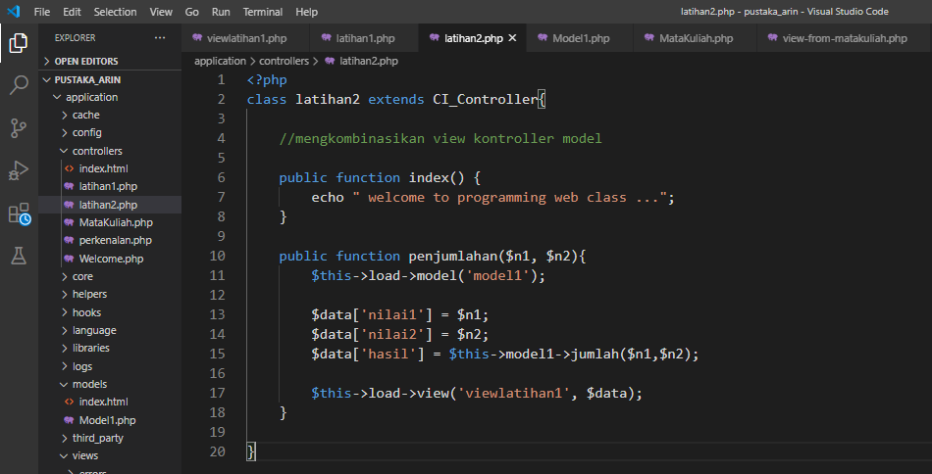

Model1.php->application/models

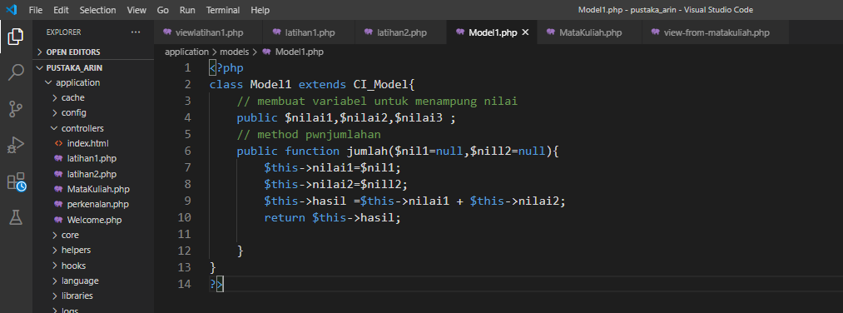

1. Hasil URL

<http://localhost/pustaka_arin/index.php/latihan1>

<http://localhost/pustaka_arin/index.php/latihan1/penjumlahan/7/9>

<http://localhost/pustaka_arin/index.php/latihan2/penjumlahan/7/9>

1. Hasil Capture

